# PULSED POWER PHYSICS TECHNOTE NO. 2020-02

TITLE: SUMMARY OF ION-BEAM FLUENCE PROFILES UNDER STANDARD CONDITIONS

AUTHOR(S): David Hinshelwood

NRL Code 6770

**DATE:** Feb 19, 2020

**ABSTRACT:**

Calorimetry data from 171 mapping shots in our standard arrangement, taken between 2012 and 2019, are examined and summarized here. There is large (~factor-of-two) scatter in these data. However, radial-profile data on these shots are fit well by a quasi-Lorentzian function, and within the experimental scatter the same fit is applicable to both low-voltage and high-voltage shots. As the distance from the anode increases, the profiles broaden and shorten consistently so that the radially-integrated beam energy is constant at about 20 kJ. This is roughly 2/3 of the initial ion-beam energy inferred from the electrical signals and from Paul Ottinger’s analytic model. The fit is described by the equation

Where ***D*** is the axial distance, ***r*** is the radius (both in cm), and F is in cal/cm2. This fit is not claimed to be the best fit, but it fits all data within the scatter and is a convenient function to use. Use of this equation is suggested in comparing to the results of modeling. Such modeling will be described in a future Technote.

The analysis in this note shows that scatter in central fluence arises more from variations in beam generation than in beam transport.

An extended calorimeter/pinhole-camera diagnostic has been useful in diagnosing beam trajectories, but as it exists now it does not capture the entire beam this limits the ability to diagnose the beam close to the diode. An improved, more-extensive version of this diagnostic would be very useful in the future. In particular, it may shed more light on variations in beam generation.

Unfortunately, using this fitting to infer the central fluence on data shots results in a significant (~30%) uncertainty. Clearly we are going to need better beam uniformity.

**Introduction**

This note began as a description of the LSP modeling I have done to date. In order to compare LSP results with data, I needed to get a representative picture of the beam fluence as a function of axial distance and radius. After twenty pages I decided that this picture would be more useful as a standalone Technote. A future note (out shortly) will describe the actual modeling.

Since we began in 2011 we have taken almost 1300 shots. About half of these used what we call the “standard geometry” shown in Fig. 1. Ions are born on a 13-micron polyethylene anode. A 2-micron polycarbonate foil (referred to by the trade name “Kimfol”) separates the diode and transport region. Originally the latter had a 1-Torr air ambient, but now it is generally the same vacuum as the diode. The stainless cathode has an 11.6-cm ID and roughly 2.5-mm width. The anode foil opposite the cathode is covered with a thin ring of .02-mm-thick aluminum with an ID of 11.1 cm. This is clamped by a chamfered ring with an ID of 14.2 cm. The current monitor pictured in Fig. 1 is no longer used.

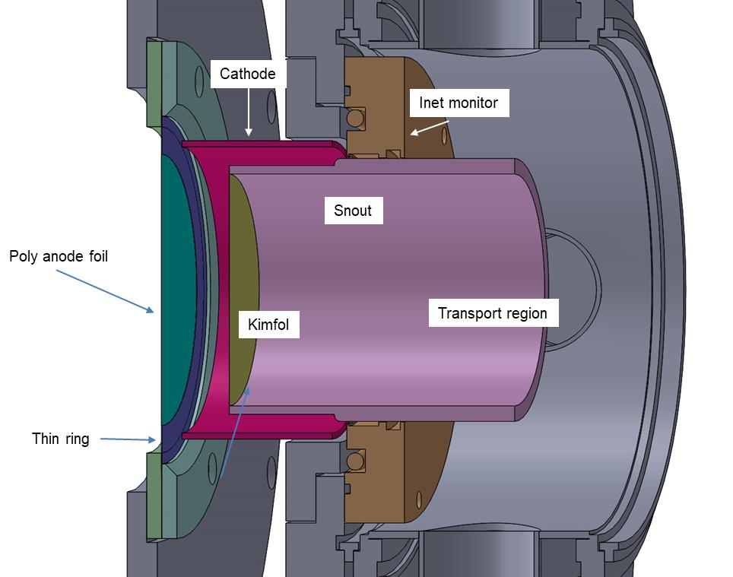

**Fig. 1:** Standard diode hardware

We have two operating conditions we call “low voltage” and “high voltage”, resulting in end-point voltages of roughly 1.3 and 1.9 MV, respectively, having anode-cathode gaps of 5.5 and 8.5 mm, respectively. The snout end (and thus the Kimfol) is set back by 1 cm for the low-voltage setup and (usually, see the following) 2 cm for the high-voltage setup.

Target arrangements are shown in Fig. 2. Typically the sample and associated diagnostics are located on axis as shown in the right photo. This is surrounded by six calorimeters at 3.8-cm radius and 8 more at 8.3-cm radius. Roughly every fourth shot is a “mapping” shot where a central calorimeter is substituted for the target. In principle, this allows us to relate the central fluence to that at the peripheral locations as a function of the anode-to-target distance. This relation then allows us to deduce the sample fluence on data shots. Because of the significantly non-uniform and non-reproducible beam, this procedure is problematic and we are left with a large (~20%) uncertainty in sample fluence. This lack of uniformity and reproducibility is the main motivation behind attempts to improve the ion source.

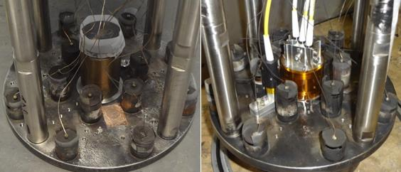\

**Fig. 2:** Target arrangements for mapping (left) and data (right) shots.

**Data**

This section looks over a subset of shots taken to date to extract the “typical” fluence distribution as a function of distance from the anode. To date (2/2020) we have taken 171 mapping shots: 86 at low voltage and 85 at high voltage. Central fluences from low-voltage shots are shown in Fig. 3. The shots are grouped based on date and operating condition and identified by 3-digit numbers. The first digit is 1 for low-voltage and 2 for high-voltage shots. The last digit is the last digit in the year the shots were taken. Here, the middle digit is 0 for 1-Torr transport ambient and 1 for a vacuum ambient.

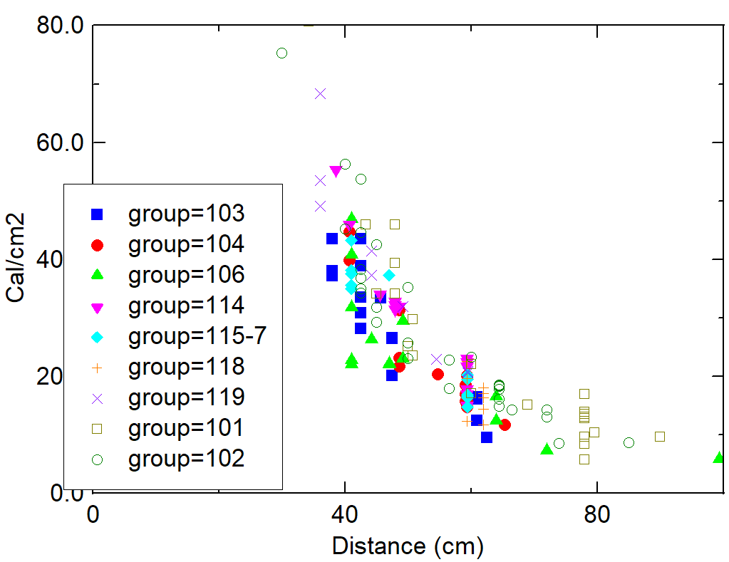

**Fig 3:** Central fluences on low-voltage mapping shots as a function of distance from the anode to the target. See the text for a description of the groups.

Several features are apparent in Fig. 3. First, there is a large, almost factor-of-two, variation in fluence at a given location. This variation has wreaked havoc when users desire a specific fluence when exposing a high-value sample. The average fluence falls off roughly as the distance squared. Thankfully, data sets taken over different years overlay within the scatter. (The sets from groups 101 and 102 were taken with a different hardware arrangement and I suspect that their slight offset may be due to a few-cm error in target distance.)

Surprisingly, these data suggest that there is no significant difference between transport in vacuum and in 1-Torr air. We know that there is finite net current at least some time during the pulse, because we see signs of arcing at contacts between sections of the outer conductor. On the other hand, both Rutherford-scattering measurements at large distances and radiachromic-film-stack measurements indicate that the beam endpoint is the same as that of the diode voltage, implying that there is no inductive loss at that time. Perhaps beam neutralization by gas ionization proceeds similarly to that by ions dragging electrons from the Kimfol. Measurement of net current and investigation of beam neutralization might be fruitful in the future.

Figure 4 shows the fluence-distance relation for high-voltage mapping shots. (There are a few data points at small distance, not shown, with fluences up to 200 cal/cm2.) Again: there is a lot of scatter; the relation does not show change over the years; and transport in 1-Torr air and vacuum appear to be the same. Group 224 (cyan) had the Kimfol setback increased from 2 to 3 cm, with no significant effect on central fluence. This is interesting because we know that moving the Kimfol much farther (~10 cm or more) back has a very large effect. Moving the Kimfol back increases the anode-Kimfol gap from 2.85 to 3.85 cm, a large relative change. If ion magnetic bending in the diode were a large effect, I would expect to see more change here.

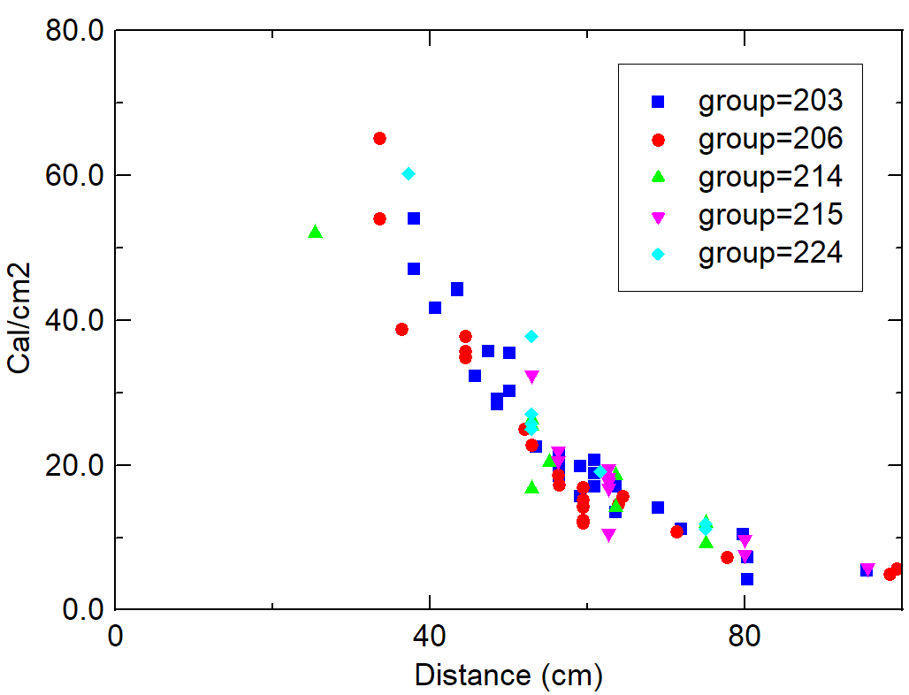

**Fig. 4:** Central fluence as a function of anode-target distance on high-voltage mapping shots.

Figure 5 compares data from low-voltage and high-voltage shots. Interestingly, they overlay within the scatter. This is fortunate from a modeling standpoint: impedance collapse is difficult to model without having moving boundaries. Figure 5 suggests that as an approximation we could model the diode using some average gap.

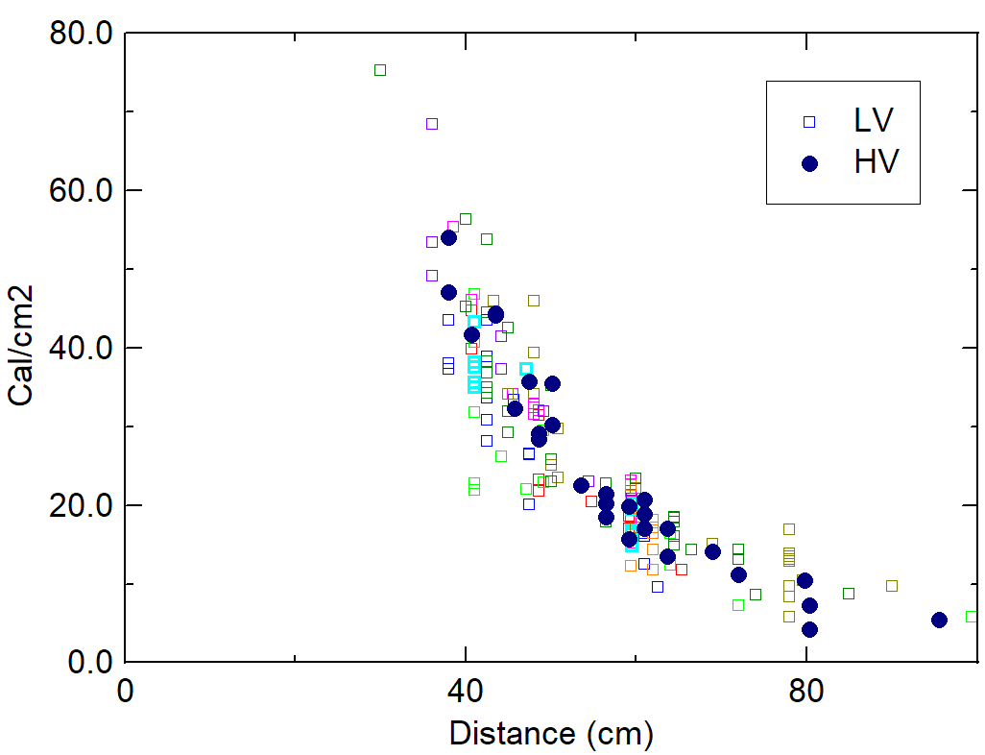

**Fig. 5:** Data from high-voltage shots in Fig. 4 shown as dark circles superimposed on data from low-voltage shots in Fig. 3.

**Fitting the radial beam profiles**

Figure 6 shows the result of a scan of the radial profile of induced radioactivity in a carbon target. On this shot a 10% transparent screen was placed behind the snout to reduce the fluence to a level that would not ablate the carbon. This is fit to a function of the form in Eq. 1. This is an interesting set of functions, defined by the exponent *P*. With *P=1* this is a Lorentzian, and as P goes to infinity the function approaches a Gaussian. The 2D (radial) integral of this function is finite for values of *P* greater than unity.

(I was unable to find a standard name for this form, and for lack of anything better called it a “Quasi-Lorentzian”, which is how it is denoted in Stella. Later, I found that Steve and Jake use a superset of this functional form to define radiographic distributions, and that this is a type of “Pearson Type VII distribution”.)

In practice, the quality of a fit to ion-diode data is very weakly dependent on the exponent used. In Fig. 6 I used P=2, but later switched to P=2.5, as is the case in all other fits shown here.

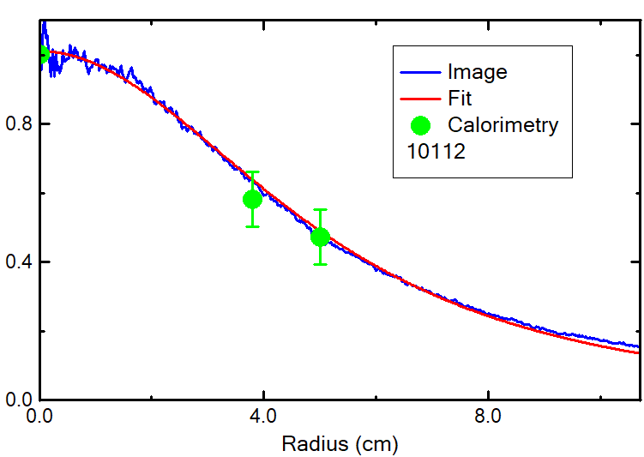

**Fig. 6:** (from the 2012 JOWOG) a radial scan of activation of a carbon target located 42 cm from the anode. The green points are typical calorimeter values. Note that the green points in Fig. 6 are only typical; the error bars shown are really too small considering the data in Figs. 3-5.

[1]

Figure 7 shows the results of 2-D nonlinear fits of calorimeter data to Eq. 1, for low-voltage shots. These fits pull out the beam center, peak amplitude, and characteristic radius. An off-center beam has the fortuitous effect of providing an array of values at differing radii, as seen in Fig. 7. These shots were arbitrarily selected from the 86 shots, and cover a range of distances. Note that the units are noted on the graphs and these vary from graph to graph. In general, the fits are good.

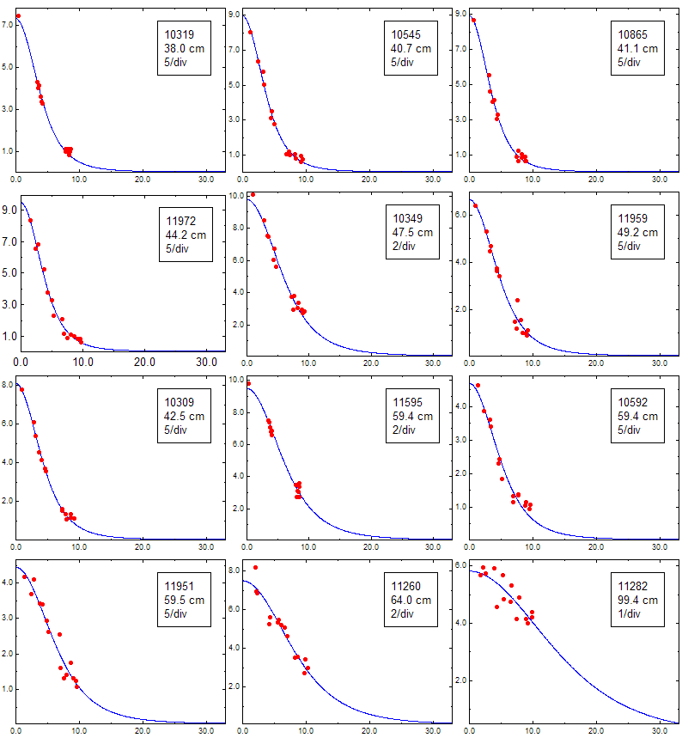

**Fig. 7:** Results of fits to low-voltage shots, using Eq. 1 with *P* = 2.5.

Figure 8 shows corresponding fits to the data from high-voltage shots.

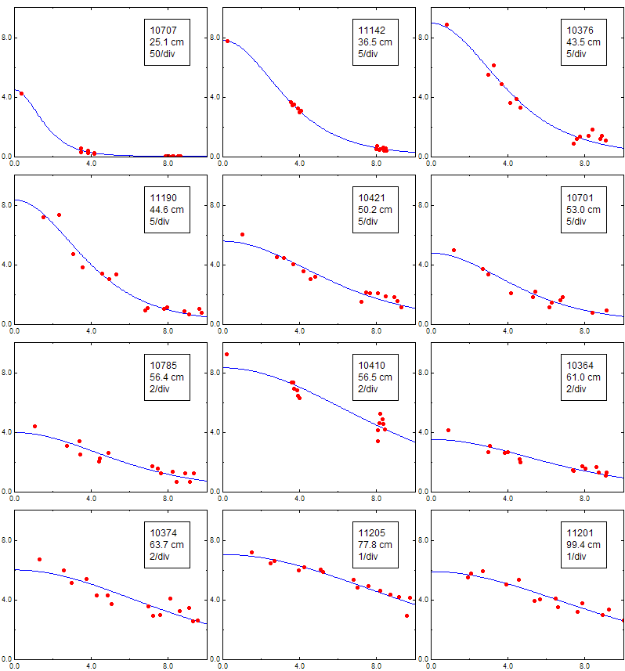

**Fig. 8:** Results of fits to high-voltage shots, using Eq. 1 with *P* = 2.5.

The characteristic radius ***a*** in Eq. 1, determined from these fits, is shown as a function of distance for both conditions in Fig. 9. The data from both sets overlay within the (large) scatter. The green line is an approximate fit that is close to the separate least-squares fits to both sets.

The use of 20 cm as a start to this fit is motivated in part by additional data that will be described later in this report.

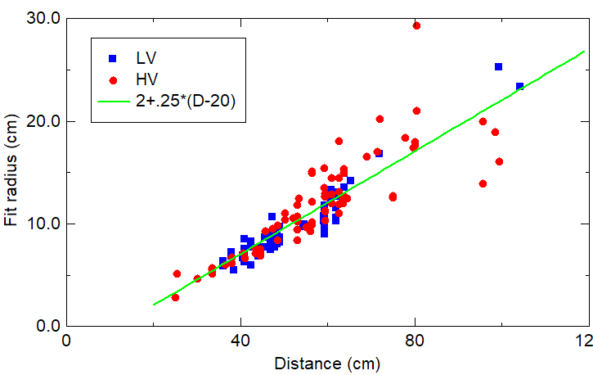

**Fig. 9:** Inferred characteristic radius (Eq. 1) as a function of distance for both types of shots.

To summarize, then, I suggest using this formula to represent the radial fluence profile from the standard ion diode as a function of distance *D*:

[2]

It remains to provide a function for the peak fluence **F0** as a function of distance.

Figure 10 compares the total beam energy at the target plane obtained by integrating the fits, to that obtained from the diode electrical waveforms. The ratio of these energies (integrated profile / electrical) is shown for both conditions in the upper left graph of Fig. 10. That these are generally below unity suggests that ions are lost close to the diode and/or the wings are larger than predicted by the fits. Neither of these is particularly surprising. The ratio is generally higher for the high-voltage shots. This seemed odd in view of Figs. 5 and 9, which indicate similar fit profiles. It turns out that the ratios differ because the higher-voltage shots have a lower calculated ion energy, as shown in the upper right graph. The total energy is actually higher for the high-voltage shots (lower left graph), which would be expected because the ~3-Ohm impedance is a better match to the 3-Ohm line than the ~2-Ohm impedance in the low-voltage case. The ion current fraction is just lower at the higher voltage. Note that the ion current is not measured now, so all of this is based only on Paul Ottinger’s well-known formulae.

Finally, the lower-right graph in Fig. 10 shows centering offsets obtained from the fits. These are significant, but contribute less to the scatter than I expected, as will be discussed.

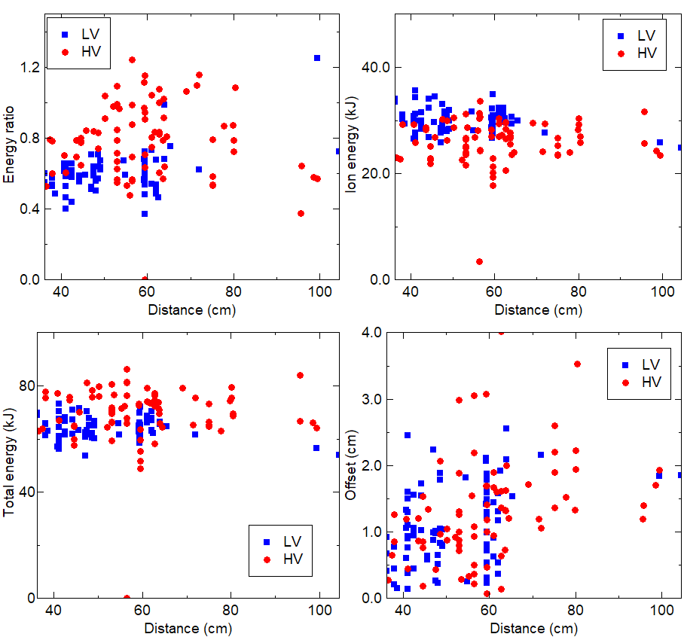

**Fig. 10:** (upper left) Ratios of ion-beam energies obtained from integrating the fit profiles to those obtained from the diode electrical waveforms; (upper right) Ion-beam energies from the electrical waveforms; (lower left) Total electrical energies; (lower right) Centering offsets.

In view of the scatter in effective radius seen in Fig. 9, and the fact that for a constant energy the central fluence scales inversely as this radius squared, we might hope that the scatter in central fluence could be explained by variations in radius, i.e., the degree of focusing. But the ratios in the upper-left graph of Fig. 10, which correct for this variation, show just as much scatter.

**Comparison with older fits**

Dave Mosher and Steve Swanekamp came up with a similarity-solution fit to the fluence profile based on LSP modeling during the 2010 timeframe. That model, in green, is compared with the current model, for a 40-cm distance, in Fig. 11.

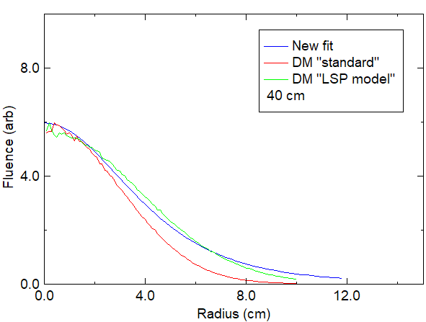

**Fig 11:** The fit here (blue) compared with profiles from Dave Mosher’s previous note.

**Central fluence as a function of distance**

The obvious approach to obtaining F0 in Eq. [2] would be to set the radially-integrated energy equal to the beam energy. But as the data in the upper-left graph of Fig. 10 show, the integrated energy is less than the beam energy, again due to a combination of error in the wings and ion loss close to the diode. From Fig. 10, we see a typical ion energy of about 30 kJ, and an efficiency (at least on low-voltage shots) of about 60%, suggesting a radially-integrated ion energy of 18 kJ. It turns out that this does not quite match the data, but 20 kJ looks pretty good as seen in Fig. 12. This fits the data to well within the experimental scatter.

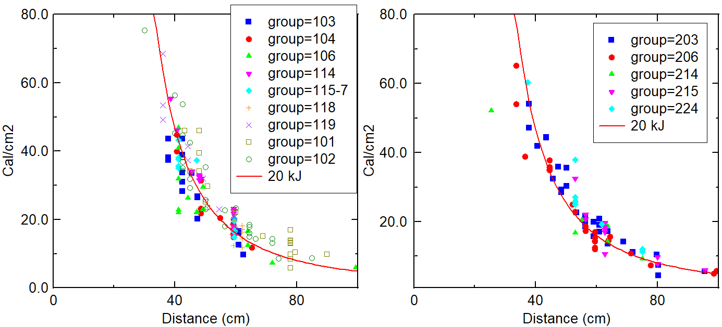

**Fig. 12:** Central fluence data from Figs. 3 and 4 with a fit determined by setting the radial integral of Eq. [2] equal to 20 kJ.

Putting this altogether gives my suggested “standard” dependence of fluence on radius and distance.

[3]

This radially-integrates to 20 kJ, which is about 2/3 of the ion-beam energy determined by electrical waveforms. LSP modeling, to be described in a future Technote, is reasonably consistent with this amount of energy loss in the diode region (i.e. ions that are lost to the cathode and snout).

Again, this is not claimed to be the best fit, but it is well within the large experimental scatter, and is an easy formula to use.

When fitting an individual shot, it may be better to adjust the factor of 2300 to fit the data, but Eq. [3] is appropriate for the nominal distribution.

**Effect of centering offset**

I had hoped that a big part of the scatter was due to the beam centering error, as in principle this might be fixable. But I don’t think this is the case. The left graph in Fig. 13 plots the ratio of peak to central fluence determined from the fits on each shot. (To be clear, the central fluence is that from the fit, not the data). For most shots imperfect centering has a small effect on central fluence. This is shown more clearly in the right graph. This graph is similar to those in Fig. 12, but now the calculated peak fluence, rather than the measured fluence, is plotted. The smooth curve is the same as the one in Fig. 12. Comparing this graph to those in Fig. 12 shows that using the peak, rather than central, value does not significantly reduce the scatter. Moreover, the same curve fits the data within the scatter. There are other reasons why we want to improve beam centering (for example, to improve the uniformity of fluence across the sample), but imperfect centering is not the major cause of scatter in central fluence.

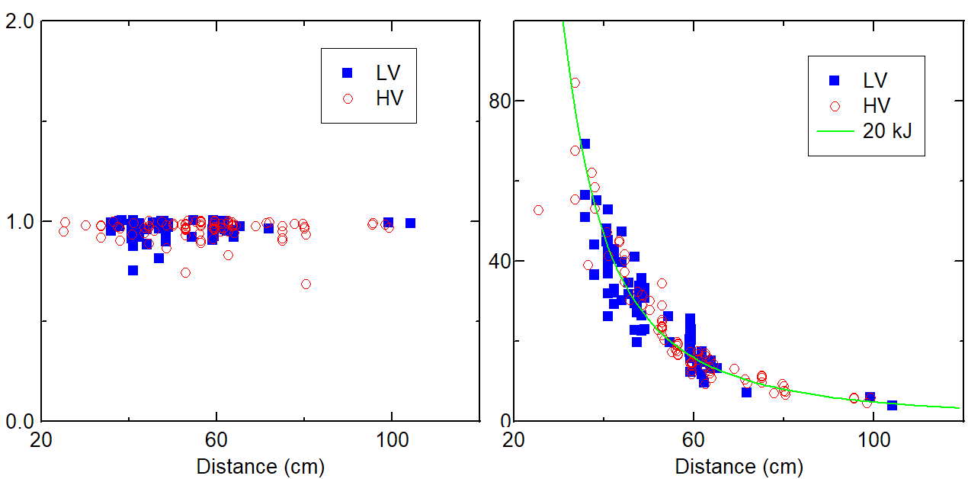

**Fig. 13:** (left) ratio of peak fluence to that on the axis, both determined from fits to the radial profiles; (right) This is similar to Fig. 12, but now the points are the peak, rather than central fluences. The curve is the same as in Fig. 12.

**Determination of the central fluence on data shots**

Although not the topic of this note, the application of profile fits to determination of the central fluence on data shots is addressed here in passing. We can check our ability to do this by fitting the mapping-shot data without using the measured central value, and seeing how well we can predict that value. Results for low-voltage shots are shown in Fig. 14. The left graph shows the ratios of central fluences derived from full fits, to those derived from fits that ignored the central value. There can be a big difference, especially at closer distances. Figure 15 shows the fits for the worst case at 42.5 cm. This problem is worse for well-centered beams, because then we only have data at two radii.

The right graph in Fig. 14 then compares ratios of fit values to the measured value. When this value is used in the fit, the agreement is good, which is not surprising. But without it we can have as much as factor-of-two errors.

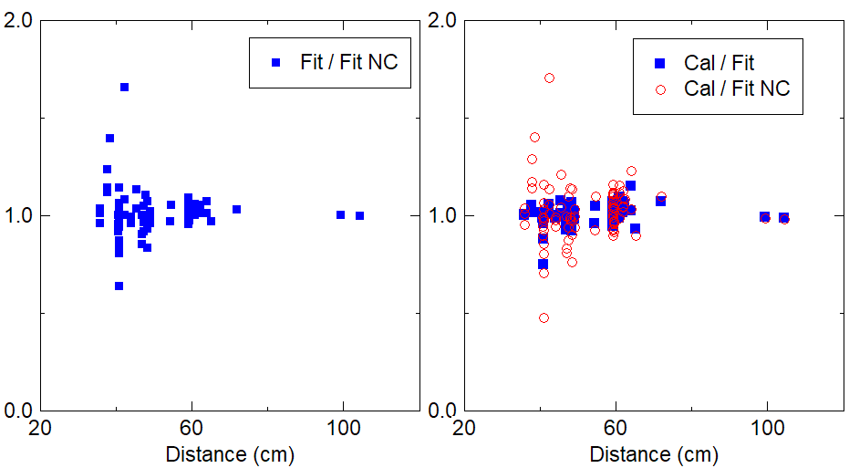

**Fig. 14:** (left graph) The ratio of central fluences obtained by fits, to those obtained by fits that ignored the measured central value, for low-voltage shots; (right graphs) Ratios of fit to measured central fluence for full (blue) and partial (red) fits.

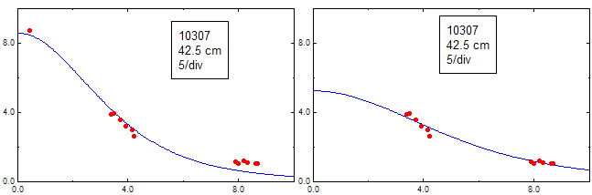

**Fig. 15:** An example of a shot whose fit changes greatly when the central value is ignored.

Figure 16 shows the same ratios for high-voltage shots. Here the discrepancy, and thus error, is even worse, and seems to show a systematic variation with distance inside 70 cm.

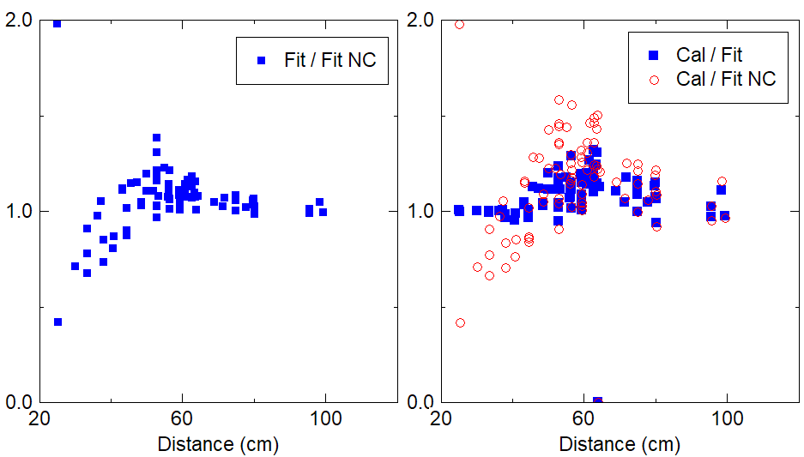

**Fig. 16:** Ratios corresponding to those in Fig. 11, for high-voltage shots.

**Data from the large-radius target assembly**

In 2017 I built an alternate assembly for beam characterization, pictured in Fig. 17. A 30-cm-diam plate has six radial spokes of 6 pinholes each, on 2-cm centers, with an additional pinhole on the axis. Calorimeters are located behind the central pinhole and those on 3 spokes. Radiachromic film is located behind the alternate 3 spokes. A typical set of exposed film strips is shown at the left of Fig. 18; these were converted to fluence as shown in the right graph in the figure. The hardware carefully indexes these strips to the pinholes.

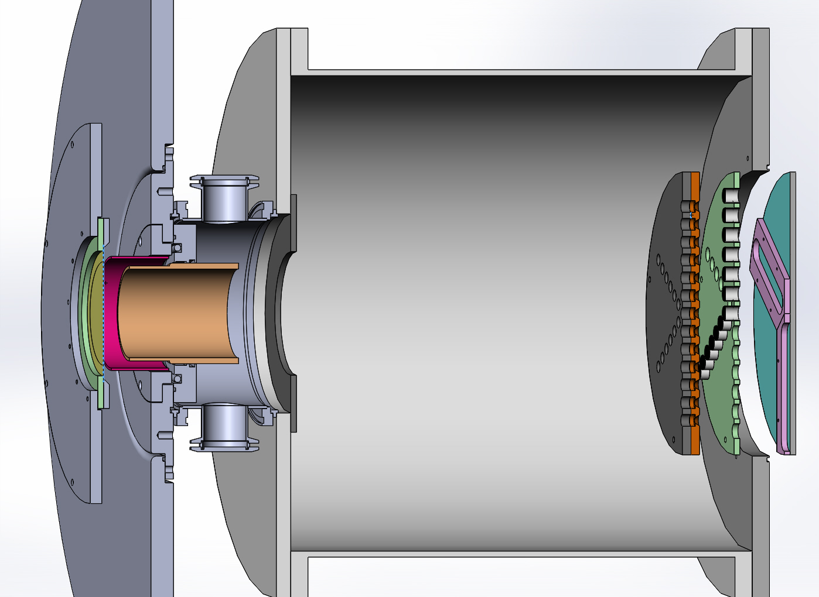

**Fig. 17:** Large-radius target assembly

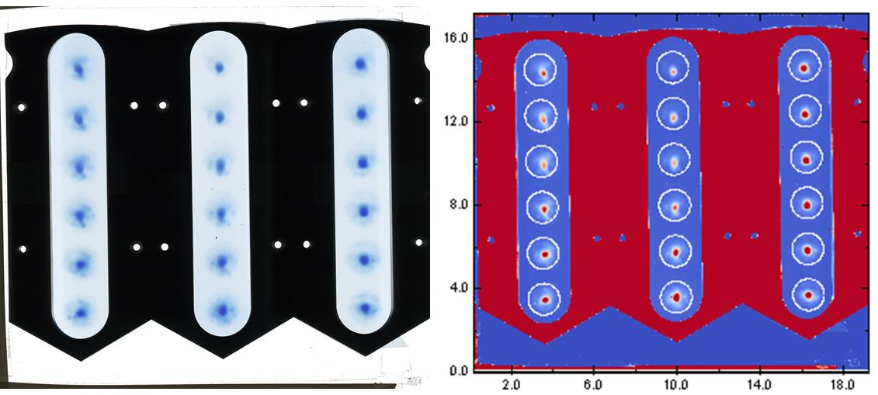

**Fig. 18:** Typical radiachromic-film exposures, converted to fluence at right. The white circles indicate the diode location when projected back through the pinholes.

Data from this array are analyzed in this way: the strips are scanned with the resulting images converted to fluence matrices as per earlier calibration. Then, for each pixel in the matrix that lies within the regions of the film that map through the pinholes back to the diode, a particle is created within a particle group. That particle has a location at the diode plane given by mapping its film coordinates back through the pinhole. It is given a weight based on the film fluence. However, the relation between film density and fluence has some uncertainty and is only linear over a fairly small range. In many cases the film exposure was outside this range. Therefore, the three calorimeters at each radius are averaged, and the particles weights for each pinhole are normalized so that their sum equals the measured fluence. This is far from perfect, because it will underweight the saturated portions of each pinhole, and so will distort the relative weights within the particles from a given pinhole. But at least it should be good pinhole-to-pinhole.

This results in a particle group at the anode plane that can then be projected to any distance. I use the ZSpread function to spread these out between the anode and the target. The resulting groups are then binned by density to give a map of fluence as a function of both radius and distance, as shown in Fig. 19.

This setup was fielded for many new diode geometries and will be the subject of a future note. We have one shot each under the standard low-voltage and high-voltage conditions, and these shots are considered here.

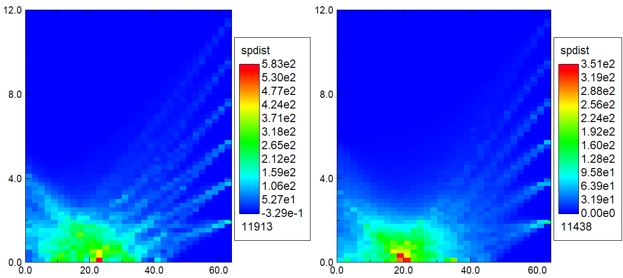

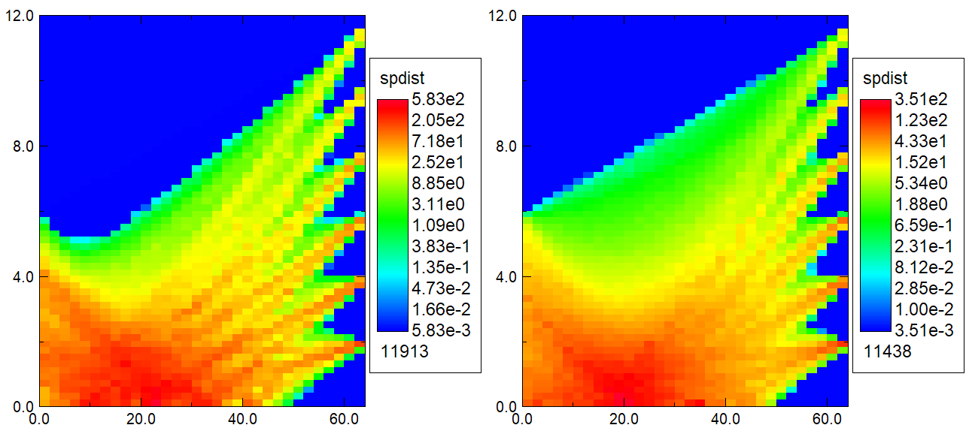

**Fig. 19:** Projections of pinhole exposure for a low-voltage (left) and high-voltage (right) shot. These are repeated in the bottom row using a log amplitude scale to highlight the weaker regions. The vertical axis corresponds to radius, the horizontal to distance, and these are not to scale.

Figures 20 and 21 compare the predictions of Eq. 3 with distributions obtained from the pinhole data. The upper-left graph is an application of Eq. 3 to the calorimetry data. Since we are comparing predictions to a single shot, the factor of 2300 in Eq. 3 was adjusted to fit the data best at the pinhole distance. Calculated curves at other distances come from Eq. 3 using this same scaling. The remaining graphs compare profiles at 20, 30, and 40 cm from the diode. The blue curves are the pinhole projections.

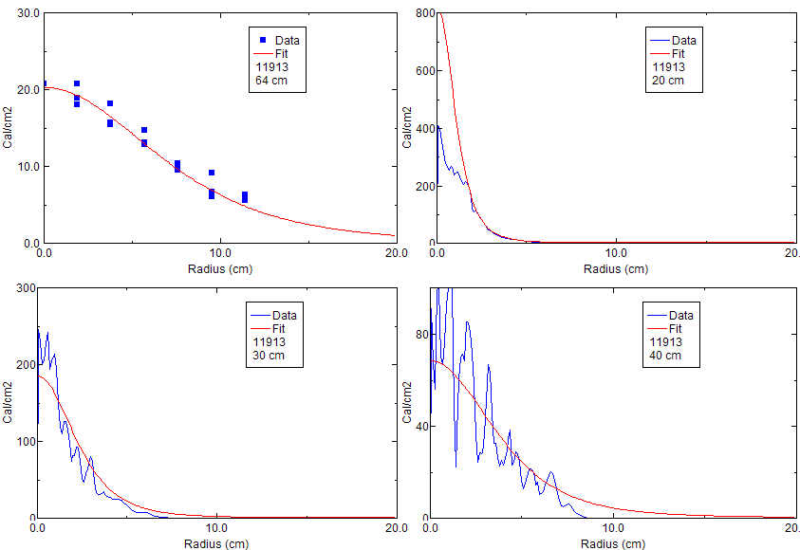

**Fig 20:** (upper left) A fit to the calorimeter data; (other graphs) fits to other distances using Eq. 3 in red, compared with radial distributions obtained by projecting the film data in blue. This is for a low-voltage shot. The red curves are scaled from Eq. 3 to match the data at 64 cm.

Reasonable agreement is seen at 30 and 40 cm, but the projection calculations seem to underestimate the central fluence at 20 cm on both shots.

Figure 22 can explain this discrepancy. These graphs compare radial integrals from the fit and from the calorimetry data for both shots. These show that there is a lot of flux predicted to be outside the diagnostic radius. As we move close to the anode, ions that reach these larger radii map back to smaller radii where they would add to the projected distribution. Thus, as we move close, the projections underestimate the actual fluence.

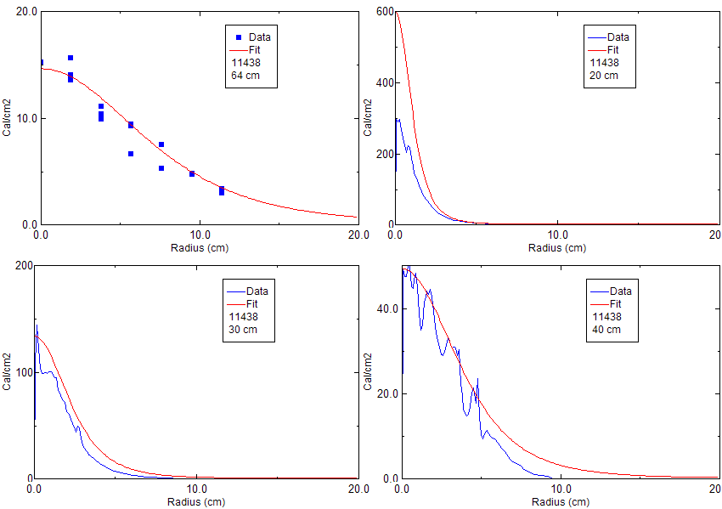

**Fig 21:** Corresponding graphs for a high-voltage shot.

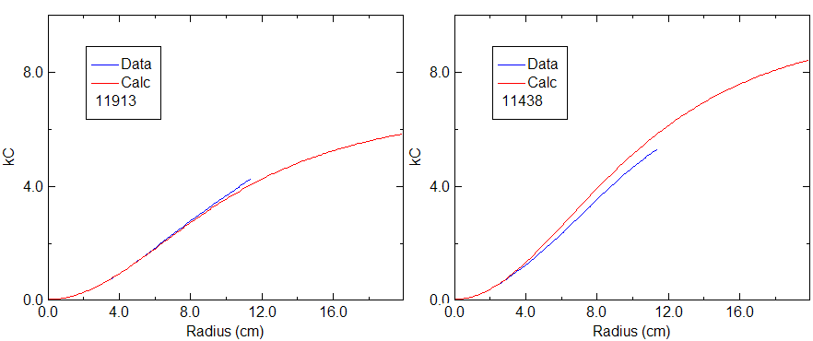

**Fig 22:** Radial integrals of the fit and calorimeter data from the upper-left graphs in the two previous figures.

It is interesting to consider predictions of the fluence distribution at the anode plane. I am speaking glibly here, since in reality projection only makes sense if the particle motion is ballistic. I am assuming that this is a reasonable assumption beyond the Kimfol (but not at all guaranteed, and this might be a good thing to look at in the future). It is certainly not a good assumption in the diode. However, little radial motion is expected between the anode and Kimfol, so I will continue to use those locations interchangeably.

The red curves in Fig. 23 are projections back to the anode (or more properly, the Kimfol). The blue curves are a very simplistic extension of Eq. 2 back through the numerical focus. It shows a much more centrally-peaked distribution than indicated by the film.

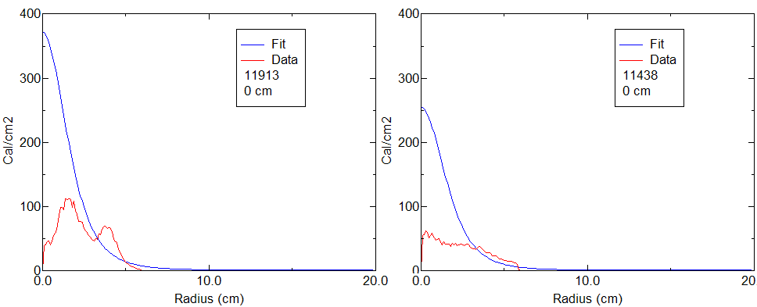

**Fig. 23:** Predictions of the fluence distribution at the anode.

Of course, there is no justification whatever for extending a far-field model of Eq. 3 into the near field. But, both LSP (to be described in a future Technote) and analytic theory predict a current density at the anode that is strongly peaked on axis. So the shapes of the blue curves in Fig. 23 are qualitatively reasonable. The red curves represent actual, though incomplete, data. They also represent the “useful” beam fluence, that is, the fluence within and near the sample radius. If we assume that the blue curves are a good qualitative approximation to the profile at the Kimfol, we see that the “useful” fluence comes disproportionally from the outer radii at the anode plane. This was predicted in the past but is nice to see confirmed.

This diagnostic is useful in characterizing “useful” ions, but it can be made more useful by either extending it to larger radius or moving it closer (the latter is not as simple as it sounds because the changing incidence angles will necessitate new hardware).

**Summary**

Calorimetry data from 171 mapping shots in our standard arrangement, taken between 2012 and 2019, are examined and summarized here. There is large (~factor-of-two) scatter in these data. However, radial-profile data on these shots are fit well by a quasi-Lorentzian function, and within the experimental scatter the same fit is applicable to both low-voltage and high-voltage shots. As the distance from the anode increases, the profiles broaden and shorten consistently so that the radially-integrated beam energy is constant at about 20 kJ. This is roughly 2/3 of the initial ion-beam energy inferred from the electrical signals and from Paul Ottinger’s analytic model. The fit is described by the equation

Where ***D*** is the axial distance, ***r*** is the radius (both in cm), and F is in cal/cm2. This fit is not claimed to be the best fit, but it fits all data within the scatter and is a convenient function to use. Use of this equation is suggested in comparing to the results of modeling. Such modeling will be described in a future Technote.

With this fit in mind, we can imagine four possible contributions to the scatter in central fluence:

1. Variations in beam generation in the diode
2. Variations in beam transport out of the cathode and snout hardware
3. Variations in beam expansion
4. Variations in beam centering

The analysis in this note shows that (4) makes at most a small contribution, and while (3) may be significant, even when correcting for it there is considerable scatter.

An extended calorimeter/pinhole-camera diagnostic has been useful in diagnosing beam trajectories, but as it exists now it does not capture the entire beam this limits the ability to diagnose the beam close to the diode. An improved, more-extensive version of this diagnostic would be very useful in the future. In particular, it may shed light on variations (1) and (2) above.

Unfortunately, using this fitting to infer the central fluence on data shots results in a significant (~30%) uncertainty. Clearly we are going to need better beam uniformity.